IMPETUS CORPORATION

EE 493 Design Studio 1

Business Statement Report

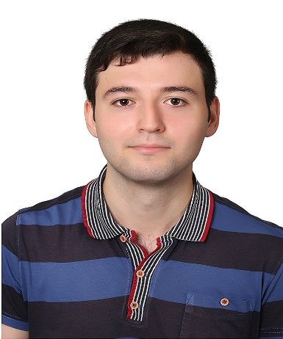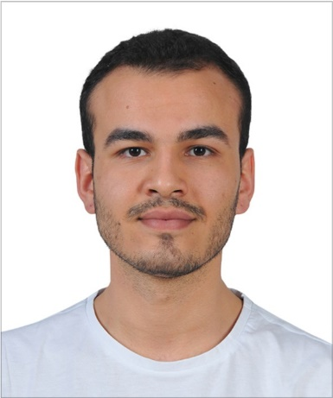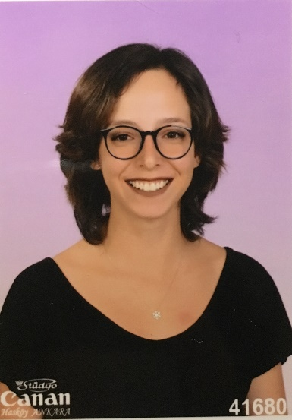

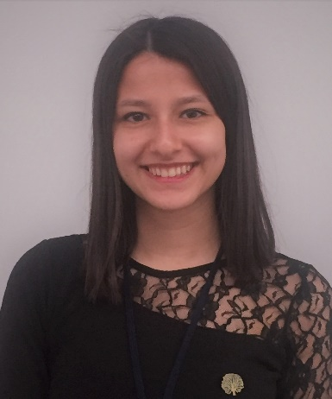

Elif Merve ÖZALP Emre Deniz ŞENEL Fahri TÜREDİ

2329746 2167237 2167435



Melike YILDIRIM Yunus YİLMAZ

2167591 2167658

Table of Contents

INTRODUCTION 3

VISION 3

MISSION 3

HUMAN RESOURCES 3

PROJECTS 3

CAT FEEDING 3

VALE PARKING 3

GIMME FAST 3

WHERE AM I? 3

CONCLUSION 3

APPENDICES 3

# INTRODUCTION

IMPETUS Corporation was established in September 2019 by five electrical and electronics engineering students at Middle East Technical University. The very first meeting of the company members took place at Çatı Cafe. The goal which brings the company members together is to produce intelligent solutions to everyday problems. The company pays attention to collect people from different fields of electrical and electronics engineering. The main specializations of the members are electronics, power electronics, and control. This field division among the members is expected to help the company to come up with distinguished approaches to various problems, as well as to create an opportunity for the members to work on their area of specialization.

# VISION

Following the guiding mind and science, our aim is to be an innovative and environmental-friendly technology company for a sustainable and livable world.

# MISSION

Primarily focusing on the needs of clients, to create innovative, reliable, time and energy efficient solutions in the field of electrical and electronics engineering.

# HUMAN RESOURCES

Since the very first gathering of the IMPETUS Corporation, diversity is an essential element of the company. Different ideas and various point of views are the keys of developing a strong culture. For this purpose, IMPETUS Corporation aims to gather experts from divergent specialization areas.

Elif Merve ÖZALP – Electronics Specialist

Specialized in electronics field. Her interests in semiconductor devices and quantum physics lead her to be in electronics division in IMPETUS Corporation.

Emre Deniz ŞENEL – Power Electronics Specialist

Specialized in power electronics and electromechanical energy conversion field. He feels enthusiastic about autonomous electric vehicles and motor drivers.

Fahri TÜREDİ – Electromechanical Systems Specialist

Specialized in electromechanical systems and design. His passion for Formula1 and electric vehicles fosters him to be a part of the IMPETUS Corporation.

Melike YILDIRIM – Control Systems Specialist

Specialized in control systems and bio robotics. Her interests mainly focus on bio-inspired intelligent machines and signal processing.

Yunus YİLMAZ – Computer and Communication Specialist

Specialized in computer systems and communication. His works on communication protocols and mobile applications lead him to be a computer specialist in IMPETUS Corporation.

# PROJECTS

## SMART CONNECTED CAT FEEDING SYSTEM

Smart connected cat feeding system is one of the projects that is assigned to EE493 students. The system must be autonomous, smart and refillable. The goal of the system is to overcome problems of manual feeding.

First of all, the system should feed only cats. If there are dogs in the feeding area, the system should distinguish and deter them from the area. The system should have a database which is some kind of feeding log. Thus, newcomers to feeding should be identified and recognized later by the system. Cats must be classified according to their weights so that different feeding regimes can be applied to them. Nothing can be attached to the animals. Because the same system can be used in different areas. Status of food supply should be observable via the internet.

The system is designed to make feeding easier. During the operation or charging, the battery level can be seen via the internet, too. So, it should be portable enough to be carried by a single person to charge it in case of a low battery. Battery should be non-removable and last for a minimum of 5 hours.

## VALE PARKING

## GIMME FAST

## WHERE AM I?

In this project, our aim is to design and implement a remotely controlled vehicle that extracts physical and magnetic map and localizes itself. The game field including physical and magnetic landmarks is required to be identified by the vehicle. Afterward, the vehicle localizes itself and estimates the position based on the information of the extracted map. Therefore, there are two main parts for the project.

The first part is map extraction where the vehicle constructs the map of a game field. It is required to identify the position and send it wirelessly to vehicle by a camera which locates at a height of 1 meter outside of the game field. The physical landmarks, which are hidden identical rigids under the surface of game field and have hill-shape with maximum height of 5 cm and maximum diameter of 10 cm, will be detected by the sensors on vehicle. The surface material of the game field should be thin, plain and opaque sheet and allows landmarks to be detected. Whereas, the magnetic landmarks are different hidden cylindrical neodymium magnets under the surface. The game field has a rectangular shape with the size of 1.5m x 2.5m. There should be total number of 10 magnetic and physical landmarks at most. Computations for map-extracting should be done on the vehicle

Localization is the second part where using onboard sensors, vehicle finds its position and sends the information of location to a computer for visualization. The position estimation will not be carried out by the camera. At the end of localization, the accuracy of estimation needs to be compared with actual positions determined by the camera. As in the case of map extraction, both the physical and magnetic landmarks are used for this part. Vehicle should be free of camera and has an appropriate size which allows itself to fit inside a cylinder with a diameter of 20 cm. Localization operation needs to be carried out in minimum time with the highest accuracy.

# CONCLUSION

In this report, we introduced our company with its name, logo and members. The identity and personal information of the company members are presented on the cover page of the report together with their picture on top. Thereafter, we shared the mission and vision statements of our company, IMPETUS Corporation. Basically, IMPETUS’ vision is to contribute the sustainability and livability of the world by targeting the innovation and environmental-friendly technology to be its core values in the guidance of science and mind. The company puts bringing innovative, time and energy efficient solutions to its clients’ needs in the realm of electrical and electronics engineering as its mission. In the following Human Resources part, we described our company composition and division of field among the members. Before the gathering of the five members of the team, we thought that it would be key to the success of the company to have five people with diverse fields of interest and ability. Hence, we formed our company with people who has relatively complementary skills and interests. In fact, we decided on the field division inside the company in the Human Resources part by taking the specialization areas of the members into account. Finally, we provided the brief descriptions of each of the four projects. We tried to answer the questions of what is the problem stated in each of these projects and what is expected from us. In response to these questions, we explained the requirements and acknowledgements of each project. Furthermore, we added our thoughts about the projects suggesting possible solution methods and approaches.

# APPENDICES

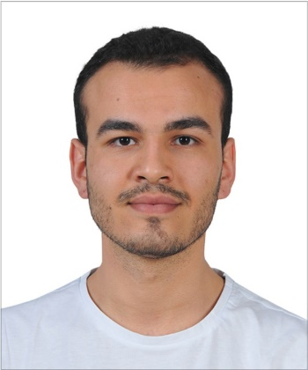**Emre Deniz ŞENEL**

Undergraduate Senior Student of Electrical & Electronics Engineering of Middle East Technical University

Location: Ankara / Turkey

Telephone: +90 539 587 02 18

E-mail: emre.senel@metu.edu.tr

Professional profile

After graduating from the high-school I became 749th in the university entrance exam (YGS-LYS) in Turkey in 2015. Currently, I am a senior student of Electrical & Electronics Engineering in METU. My interests are power electronics, electric vehicles and autonomous systems. Current, I am conducting two STAR EEE Projects in my university on induction machines and autonomous driving systems. My goal is to establish my own electrical autonomous vehicle brand.

Career Summary

**June 2019 – July 2019 ASELSAN Electronics Inc., Ankara**

**Student Intern**

*Outline*

As a summer intern, my goal was to observe defense industry and experience practical implementations of my theoretical background.

* Designed interfaces using MATLAB and GUIDE software.
* Analyzed intrinsic and extrinsic parameters of cameras.
* Implemented a simulation software of a camera.
* Analyzed different feature detection and feature extraction algorithms.
* Tested runtimes of different matching algorithms.

**July 2018 – September 2018 TOYOTA Motor Manufacturing Turkey, Sakarya**

**Student Intern**

*Outline*

TOYOTA’s manufacturing system is observed. Analyzed assembly division problems and conducted a symptom management project in maintenance engineering department.

* Controlled and observed the manufacturing process of the TOYOTA assembly factory.
* Joined to the meetings and observed how project management is done.
* Conducted a symptom management project which is a dust sensor.
* Joined Programmable Logic Controller tutorials and built a short-run code.

Education and qualifications

* **Electrical & Electronics Engineering B.S,** Middle East Technical University, 2015 – Present (Currently Senior Student), CGPA 3.44/4.00
* **High School Graduate,** Gazi Anatolian High School, 2011 – 2015, Grade 93.06/100.00
* **Primary School Graduate,** Evrensel Primary School, 2004 – 2011

Projects and Publications

**Coordination of Autonomous Electrical Vehicles for Energy Efficient Driving**, METU EEE STAR Project, May 2019 - Present

**Induction Machine Test Setup Development**, METU EEE STAR Project, May 2019 – Present

**Pinball Game Design with VHDL**, METU EEE Logic Design Project, February 2019 – June 2019

**Wireless Communication System Design,** METU EEE Analog Design Project, September 2018 – February 2019

**Fire Alarm System Design**, METU EEE Circuit Laboratory Project, February 2018 – June 2018

**Solar Tracking System Design,** METU EEE Circuit Laboratory Project, September 2017 – February 2018

Organizations and Achievements

**Aegean Conference on Electrical Machines and Power Electronics (ACEMP)**, August 2019, Turkey – Organization Team Member

**Borusan Atölye Robothon**, November 2019, Turkey – Winning Team Member

Skills

* MATLAB Programming
* C Programming
* MS Office
* Simulink
* VHDL Programming
* Leadership
* Teamwork

Languages

* **Turkish** - Fluent
* **English -** Advanced
* **French** – Elementary

Hobbies

* Chess
* Bass Guitar
* Formula 1
* Fitness